WEB DEVELOPMENT ASSIGNMENT REPORT

THREE CODING PROJECTS
Submitted by: YOGITHA ORSU
Course: B.Tech – First Year
Branch: Computer Science and Engineering (CSE(DATA SCIENCE))
College: NRI University
Subject: Web Development

PROJECT 1: COLLEGE FEST MANAGEMENT WEBSITE

1. Aim / Objective
To develop a responsive College Fest Management Website that displays cultural events, workshops, schedules, event coordination rules, and registration forms.

2. Technologies Used
- HTML
- CSS

3. Description
This website provides information about college fest activities. It displays event details, workshop information, schedules, rules, and registration forms. The website uses styling and responsive design to improve the user experience.

4screenshot of Final Output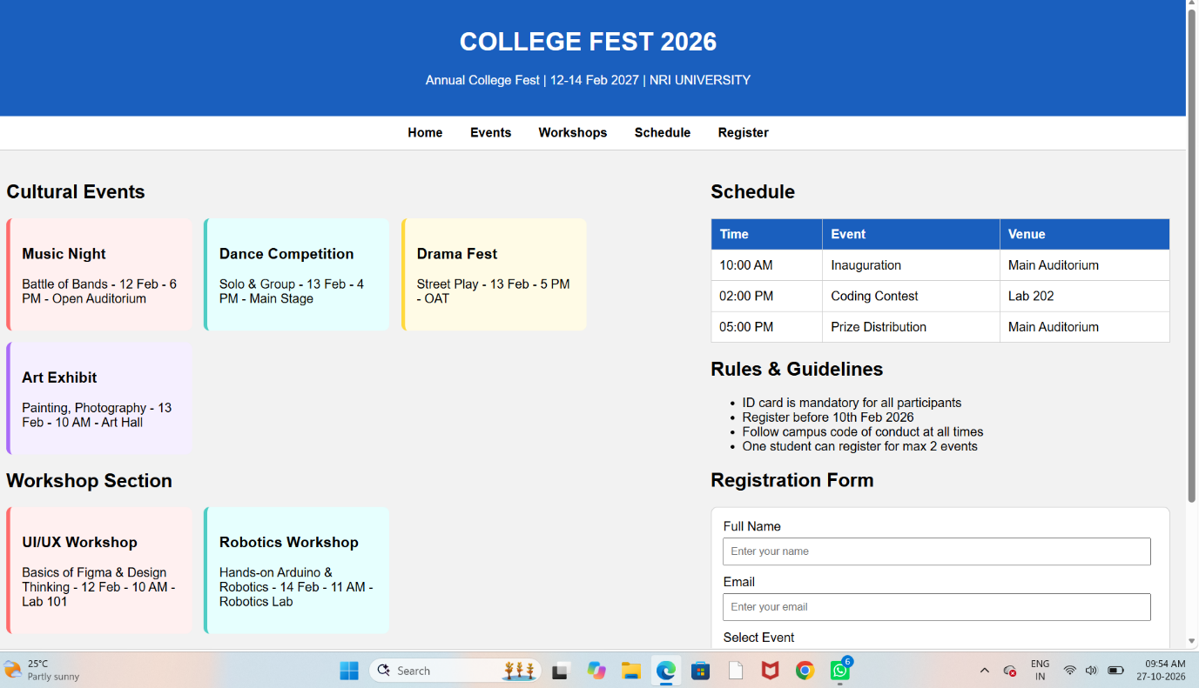

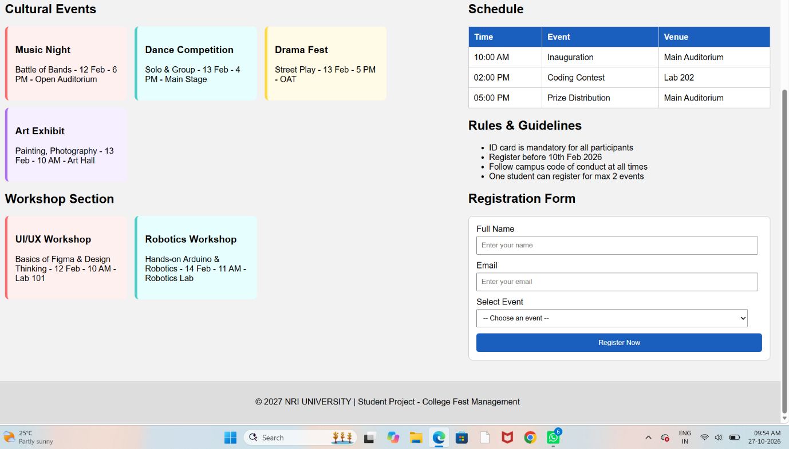

5.Result
The College Fest Management Website was developed to display college events and provide information about schedules, workshops, rules, and registrations.

PROJECT 2: PERSONAL PORTFOLIO WEBSITE

1. Aim / Objective
To create a personal portfolio website that presents my personal information, educational details, skills, and resume in a professional format.

2. Technologies Used
- HTML
- Css

3. Description
The personal portfolio website introduces the student and displays educational information, skills, and resume details. CSS is used to style the website and make it attractive and easy to navigate

4. Screenshot of Final Output
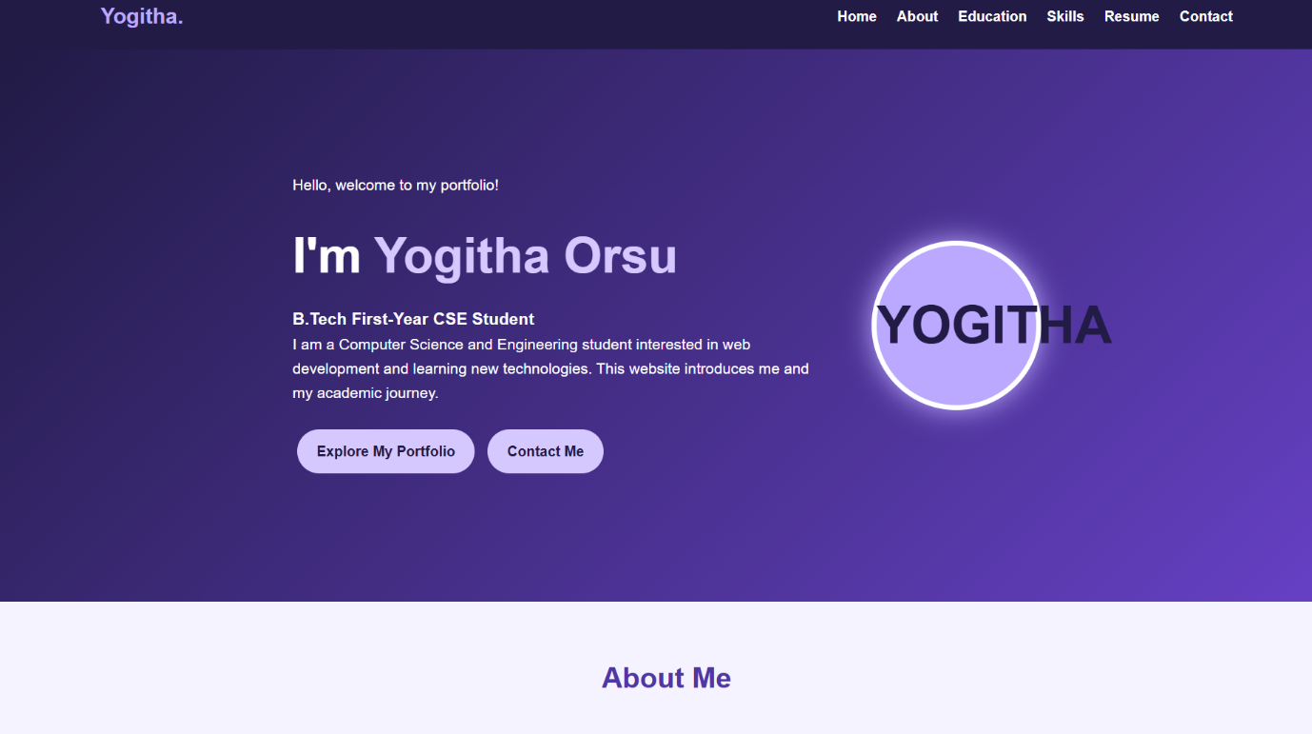
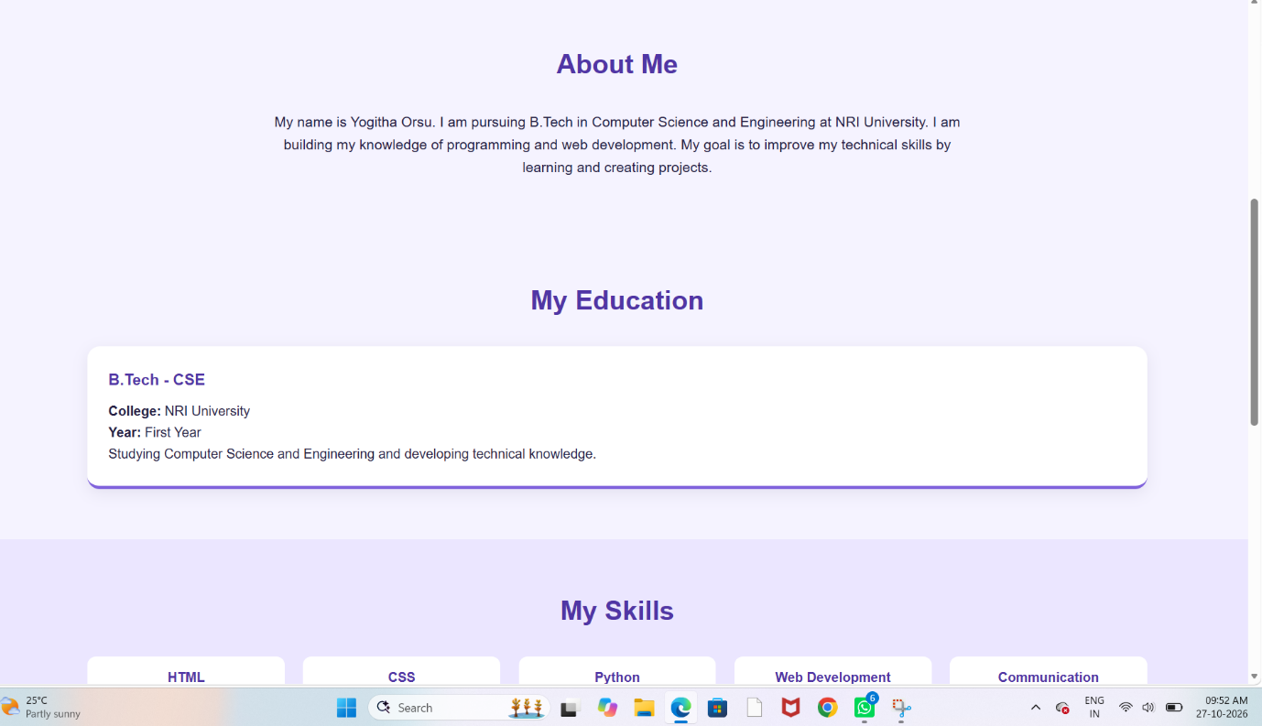

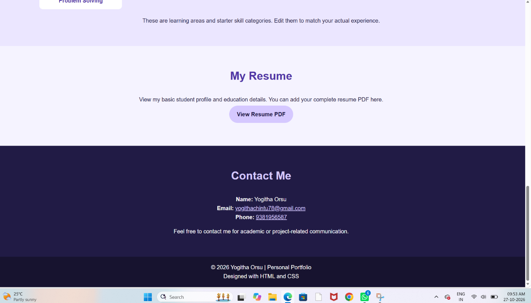

5. Result
The Personal Portfolio Website was developed to present personal and educational information in an organized and professional way.

PROJECT 3: ______________________________

1.AIM

. Trekking Designing Website

The aim of this project is to design and develop an attractive, user-friendly, and responsive trekking website using HTML and CSS. The website provides information about trekking destinations, adventure activities, travel packages, safety guidelines, and booking details. It helps users explore trekking location.

2. Technologies Used
- HTML
- CSS
- JavaScript (if used)

3. Description
The Trekking Designing Website helps users explore beautiful trekking destinations, adventure activities, and trekking packages. It is designed using HTML and CSS with attractive colours, images, and a user-friendly layout.

4. Screenshot of Final Output

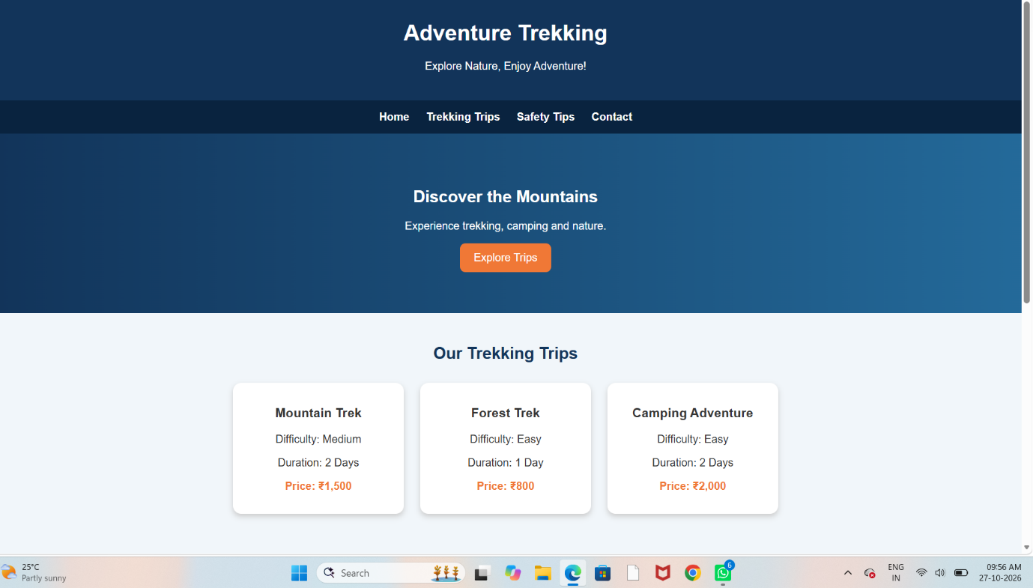

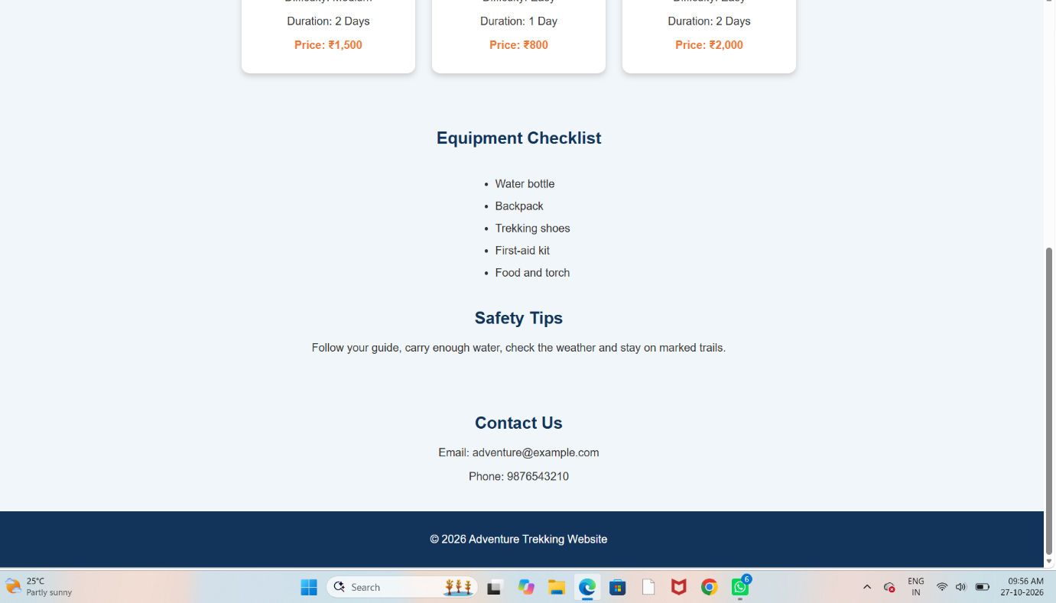

5. Result
The project was developed to apply the basic concepts of web development and demonstrate the final webpage output.

CONCLUSION
Through these three projects, I gained practical experience in designing webpages using HTML and CSS. These projects helped me understand webpage structure, styling, layout design, and the importance of creating user-friendly websites.

